**Q) 1. Open -** [**https://www.techlistic.com/p/demo-selenium-practice.html**](https://www.techlistic.com/p/demo-selenium-practice.html)

**2. Print the values of the table column-wise. (Google-Meta-Microsoft and so on)**

**Answer**

package tables;

import org.openqa.selenium.By;

import org.openqa.selenium.WebDriver;

import org.openqa.selenium.WebElement;

import org.openqa.selenium.chrome.ChromeDriver;

import java.util.ArrayList;

import java.util.List;

public class ColumnData {

public static void main(String[] args) {

//giving path to where chrome driver is downloaded

System.setProperty("webdriver.chrome.driver", "C:\\Users\\Pallavi.Arora\\Downloads\\chromedriver_win32\\chromedriver.exe");

WebDriver driver = new ChromeDriver();

//maximizing the window which opens

driver.manage().window().maximize();

//deleting all the cookies and cache

driver.manage().deleteAllCookies();

//opening url

driver.get("https://www.techlistic.com/p/demo-selenium-practice.html");

//locating table

WebElement table = driver.findElement(By.xpath("//table[@id='customers']"));

//creating list for storing column data

List<WebElement> columnCells;

//traversing the columns and storing data

for(int i=1;i<4;i++){

columnCells = table.findElements(By.xpath(".//td[" + i + "]"));

//printing the data

for (WebElement columnCell : columnCells) {

System.out.println(columnCell.getText());

}

}

//closing instance

driver.quit();

}

}

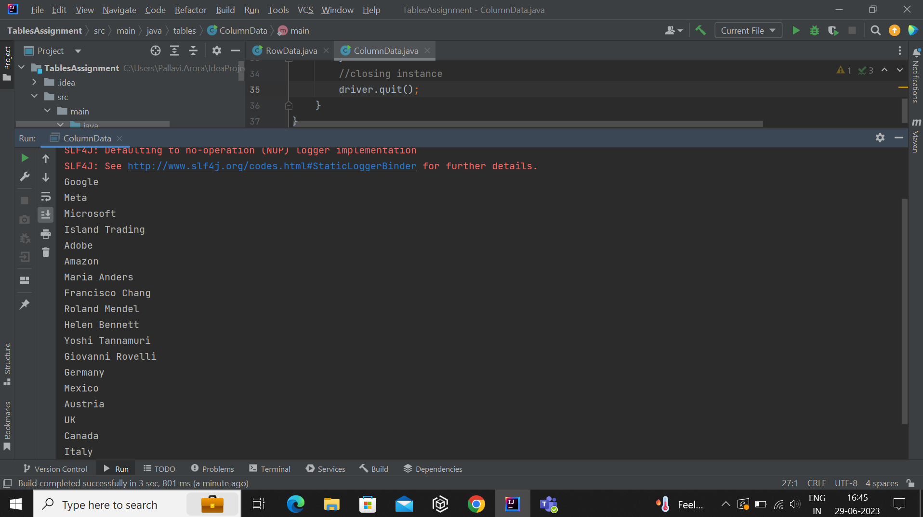

**3. Print the values of the table row-wise. (Google - Maria Anders - Germany)**

**Answer**

package tables;

import org.openqa.selenium.By;

import org.openqa.selenium.WebDriver;

import org.openqa.selenium.WebElement;

import org.openqa.selenium.chrome.ChromeDriver;

import java.util.ArrayList;

import java.util.List;

public class RowData {

public static void main(String[] args) {

//giving path to where chrome driver is downloaded

System.setProperty("webdriver.chrome.driver", "C:\\Users\\Pallavi.Arora\\Downloads\\chromedriver_win32\\chromedriver.exe");

WebDriver driver = new ChromeDriver();

//maximizing the window which opens

driver.manage().window().maximize();

//deleting all the cookies and cache

driver.manage().deleteAllCookies();

//opening url

driver.get("https://www.techlistic.com/p/demo-selenium-practice.html");

//locating table

WebElement table = driver.findElement(By.xpath("//table[@id='customers']"));

//storing rows of the table in a list

List<WebElement> rows = new ArrayList<>(table.findElements(By.tagName("tr")));

//printing data

for(WebElement row:rows){

System.out.println(row.getText() + " ");

}

driver.quit();

}

}

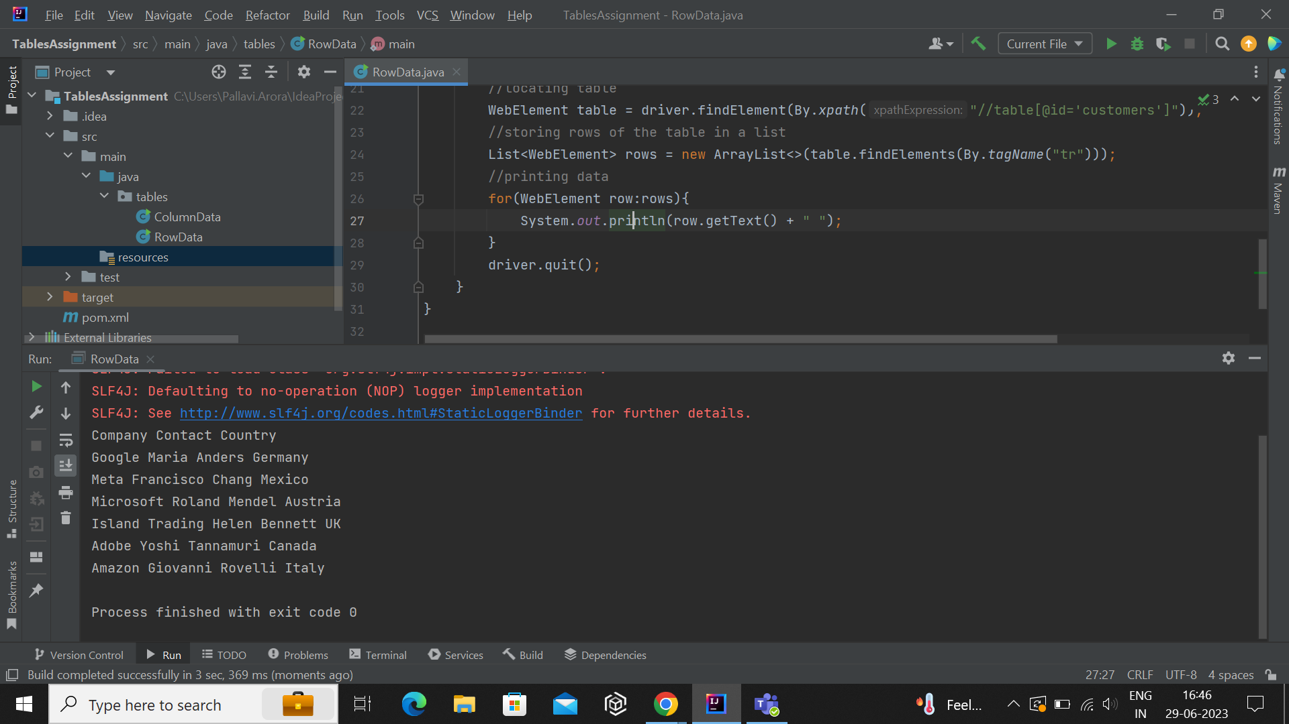

**4. Verify that Roland Mendel works in Microsoft and lives in Austria**

**Answer**

package tables;

import org.openqa.selenium.By;

import org.openqa.selenium.WebDriver;

import org.openqa.selenium.WebElement;

import org.openqa.selenium.chrome.ChromeDriver;

public class Roland {

public static void main(String[] args) {

//giving path to where chrome driver is downloaded

System.setProperty("webdriver.chrome.driver", "C:\\Users\\Pallavi.Arora\\Downloads\\chromedriver_win32\\chromedriver.exe");

WebDriver driver = new ChromeDriver();

//maximizing the window which opens

driver.manage().window().maximize();

//deleting all the cookies and cache

driver.manage().deleteAllCookies();

//opening url

driver.get("https://www.techlistic.com/p/demo-selenium-practice.html");

//locating table

WebElement table = driver.findElement(By.xpath("//table[@id='customers']"));

//getting value of name

String name = table.findElement(By.xpath("//table[@id='customers']/tbody/tr[4]/td[2]")).getText();

//getting company

String company = table.findElement(By.xpath("//table[@id='customers']/tbody/tr[4]/td[1]")).getText();

//getting country

String country = table.findElement(By.xpath("//table[@id='customers']/tbody/tr[4]/td[3]")).getText();

//verifying if name, company and country match the required name, company and country

if((name.contains("Roland Mendel")) && (company.contains("Microsoft")) && (country.contains("Austria"))){

System.out.println("Roland Mendel works in Microsoft and lives in Australia");

}

else{

System.out.println("Not verified");

}

//exiting the instance

driver.quit();

}

}

